**K5 Planner**

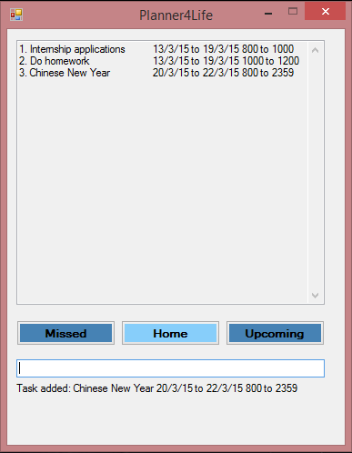

**Supervisor:** Huang Da **Extra feature:** Recurring Tasks

|  |  |  |  |
| --- | --- | --- | --- |
| Sakib Bin Farooque Rahmatullah  Team lead, Deliverables and Deadlines | image2  Le Minh Thu  Documentation, Integration | Passport photo  Karthikeyan s/o Shanmugam  Testing, Code Quality | image4  Lee Thye Jie  Scheduling and Tracking, Testing |

**Planner4Life USER GUIDE**

Congratulations on downloading Planner4Life User Guide! Planner4Life is your new companion for life. It keeps track of your various tasks and deadlines. This User Guide provides you with detailed descriptions of Planner4Life's functionalities to enable you to use it effectively.

**What is Planner4Life?**

Planner4Life's primary function is to organize your tasks and deadlines. As a user you can add a Task on a particular date and attach the desired information to that task.

Planner4Life will then display these tasks in chronological order so that you always stay on top of your work!

**Anatomy of K5**

**Types of Views**

Planner4Life consists of 3 Views for uncluttered access: Home, Upcoming and Missed. The current View is indicated by a highlighted button with its View name. Users may switch between Views by selecting the corresponding buttons, or by keying in <home>, <upcoming> or <missed> for their respective views.

Home View



The Home View displays all the tasks for the current day and the next consecutive 7 days. Tasks that have no date indicated are also shown in the Home View.

Upcoming View



The Upcoming View displays all the tasks with dates past the coverage of the Home View. Users are able to browse distant and recurring tasks in this View.

Missed View



The Missed View displays all the tasks with a due date that has passed. When a task has passed without completion, the Missed button will turn red to notify the user that he has missed a deadline.

**Keying in Tasks**



Users key in tasks in the text bar that can be found below the View buttons. Tasks are processed when the <Enter> key is pressed.

**Operation Feedback**



After each successful operation, Planner4Life will display feedback below the user input bar to let the user know what has happened. A useful prompt is also always present to remind the user to the type of input that is expected. Displayed above is the feedback for *edit*.

**Command Formats**

There are 7 basic commands: *add, delete, undo, search, clear, edit* and *help*.

**1. Add a task**

Input format: *add* <task description>; date <start date> to <end date>; time <start time> to <end time> #impt

The *add* function allows you to enter information fields into Planner4Life and store your tasks. Separate information fields are separated with the < ; > symbol. Information fields are input with a preceding keyword. The full list of keywords can be found below.

The order of the information fields entered does not matter. Irrelevant information fields can also be left out as well.

If the operation is successful, a prompt will appear below the input bar as confirmation.

|  |  |
| --- | --- |
| **Keywords** | **Function** |
| date <start date> to <end date> | To specify start and end dates.  The date input format is ddmmyy. |
| time <start time> to <end time> | To specify time period i.e. time 8pm to 1am.  Time is input in 2400hr format. |
| #impt | marks the task as important. |

Examples

add meeting at office; time 0930 to 1030; #impt

add concert at esplanade

add assignment; date 020515 to 270215

**2. Edit a task**

Input format: *edit* <task index >; <key in new task in *add* format>

The *edit* function allows the user to edit specific details of an existing task.

Each task shown on the screen is numbered in increasing order. To edit a task, identify the desired task number and re-enter the task to make the change. A detailed example is shown below.

If the operation is successful, a prompt will appear below the input bar as confirmation.

Example

Original task: 2. meeting 02/02/15

Enter: *edit* 2; add meeting; date 030315

Final task: 2. meeting 03/03/15

**3. Delete a task:**

Input format: *delete* <task index>

The *delete* function allows the user to delete tasks identified by its corresponding task number.

If the operation is successful, a prompt will appear below the input bar as confirmation.

Example:

Task to delete: 3. Meeting in office 0900

Command: delete 2

**4. Clear tasks:**

Input format: *clear* followed by <Y> or <N>

This command clears all the tasks in K5 Planner. Upon pressing entering *clear*, a dialog bar will appear asking you to confirm your operation. Enter <Y> for Yes or <N> for No. Do note that *clear* cannot be undone and will delete all your information from the database.

**5. Undo:**

Input format: *undo*

This command undoes accidental deletes, edits or adds.

This command can only be executed immediately after a successful *delete*, *add* or *edit* command.

|  |  |
| --- | --- |
| **Function** | **Effect of *undo* on function** |
| Add | Removes the previously added task |
| Delete | Replaces the previously deleted task |
| Edit | Restores the original task before the commit |

**6. Search:**

Input format: *search* <target word>

The search function allows the user to search for a <target word> in all tasks in the planner. All  
tasks that contain the <target word> will be displayed in the Display Window. There will be an  
index number associated with each search result and users can reference this number for future  
operations.

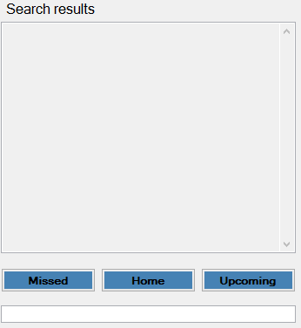

1. 09/02/15 Do assignment
2. No Date Do Tutorial 1

Search do

**7. Help:**

Input format: *help*

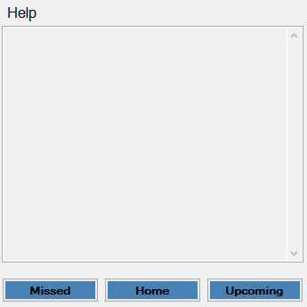This command displays a help list in the Display Window that lists down the various commands and their functions.

Add add entries

Edit edit task contents

Delete delete tasks

Clear clears the entire planner

Undo undo the previous add, edit or delete

Search search for keywords throughout all tasks

**Appendix A: User stories - As a user, I can…**

**High Priority**

|  |  |  |
| --- | --- | --- |
| **No.** | **Functionality (As a user I can…)** | **Purpose** |
| 1 | add tasks in a single command | so that I work faster |
| 2 | delete tasks in a single command | so that I work faster |
| 3 | undo changes quickly | so that my mistakes are not permanent |
| 4 | use the search feature | to search for any tasks from the list |
| 5 | can change specific details in tasks | so that I don’t need to delete the old entry and enter a completely new one |
| 6 | view my tasks categorized by importance | so that I know which one needs more attention |
| 7 | view my tasks in chronological order | so I know which to do first |
| 8 | mark my tasks as completed | so I know which are done |
| 9 | add start and end tasks for a task | so that I know when to start and end the task |
| 10 | can receive notifications for upcoming deadlines | so that I know a task needs to be completed soon |
| 11 | I can record: Tasks, Time, Venue, Remarks | so I can view and edit them individually |
| 12 | I know that there is a save feature | so that when I close and reopen the app, my information is saved |
| 13 | I can navigate through the tasks easily | so I can view the list easily |
| 14 | I can view past tasks and events | if I ever need to recall anything |
| 15 | I can scroll down the list of items | to view the list easily |
| 16 | I can click on help if I am unsure | so that I can refer to the commands and shortcuts |
| 17 | I can enter recurring tasks easily | so that I don’t have to enter them one by one |
| 18 | I can save the storage file anywhere | so that I can access it on different computers |
| 19 | I can use the application even without Internet | so that I can use it anywhere |

**Medium Priority**

|  |  |  |
| --- | --- | --- |
| No. | Functionality (As a user I can…) | Purpose |
| 1 | receive notification for missed deadlines | so that I know that a deadline has been missed |
| 2 | hide outdated tasks | so that if I don’t want to view them, they won’t be on the screen |
| 3 | use hotkeys to access the application | so that it is easily accessible |
| 4 | choose to have the application open in one corner of the screen | so I can easily view upcoming tasks |

**Low priority**

|  |  |  |
| --- | --- | --- |
| No. | Functionality (As a user I can…) | Purpose |
| 1 | enter tasks using short form | so that it is faster |
| 2 | be notified if the task being entered has a duplicate | so that I can avoid duplication |
| 3 | can add checklists to multi-stage  tasks | so that I can keep track of smaller tasks that fall under a major task |
| 4 | I can block multiple time slots if unsure about a task and the application will automatically delete the other time slots when one is confirmed | so that I can place task in planner even without a confirmed timing and prevent clashes |
| 5 | I can sync my tasks to other devices | so that I can use the planner from other devices |
| 6 | I can have suggested words that I commonly use | so that I can type faster |
| 7 | I can sync my planner with Google Calendar | so that I can use both the application and google calendar |

**Appendix B: Non-Functional Requirements**

|  |
| --- |
| **Requirement** |
| K5 should automatically save any changes made after each action performed |
| K5 should be able to save calendars as readable text files so that the user can easily edit the contents directly if he/she so wishes |
| K5 should be able to run as a standalone .exe file |
| K5 should be able to perform CRUD functions with no perceivable lag time |
| K5 should be compatible with computers that run Windows XP, Windows Vista, Windows 7 and Windows 8.1 Operating System with Microsoft .NET framework 4.0 installed |
| K5 should maintain a clean UI that can be easily read at all times |
| K5 should conform to C++ coding standards so that other developers can pick up the project |
| Development of K5 should be documented diligently so that the development process is accountable |

**Appendix C: Product survey**

|  |
| --- |
| **Product**: Any.do  **Documented by**: Karthikeyan s/o Shanmugam  Strengths:   * Easy to add new tasks – just click add and type in task and hit enter * Easy to mark as done – just mouse over task, click on the tick icon that appears * Easy to update and delete * Tasks marked as done continue to appear at the bottom with a strikethrough allowing user to keep track of work that is done. * Can sync with phone and computer as long as there is internet. * Good categorisation - can sort according to “today, tomorrow, upcoming, someday” or into groups “personal, work, <add own name> etc” * Can add a text note (picture, video, camera, attachment, voice recording) * Can add subtasks * Can add Reminders for tasks * Can collaborate tasks with other people using same application * Can mark tasks as important or special attention * Can order tasks according to importance/priority * GUI is simple, sleek and easy to use * Has good flexibility since it is not really a command input type organiser. Just input exactly what the task is, and it appears as so. * Can search for tasks by typing in keywords * Supports recurring tasks   Weaknesses:   * Web-based application – so there is a need to go to the site to use it. Not a desktop application * Since its web based, it cannot be accessed on computer without internet. Possible to access in on phone app without internet access. * Cannot undo changes * No support for timed task. Since its purely text based, not like a calendar where it is possible to block out time, it will not be able to tell if there is a clash in timing of task |
| **Product**: S Planner  **Documented by**: Le Minh Thu  Strengths:   * Ability to sort tasks in chronological order of due dates * Ability to sync tasks to Google Calendar, which can be accessed using computer * Ability to differentiate tasks of different priorities * Ability to notify conflicting events * Ability to use the program without internet   Weaknesses:   * Cannot categorize tasks according to user’s preferences * Cannot clear the entire list of tasks |
| **Product**: Outlook Calendar  **Documented by**: Lee Thye Jie  Strengths:   * Allows syncing across devices * Colour-coded entries for different categories * Ability to import/export new calendars * Clear indication of the current day * Extensive information fields for individual entries e.g. Location, Reminder etc. * Simple, clear interface   Weaknesses:   * No search function * Unable to add tags to entries * If there are too many entries on a day, the newer entries are not visible until the view mode is changed |
| **Product**: Google Calendar  **Documented by**: Sakib Bin Farooque Rahmatullah  Strengths:   * Ability to take in info by single command * Ability to colour code items * Ability to rank items by priority * Ability to set reminders * Ability to add locations * Ability to add remarks * Ability to set durations * Ability to recurring events   Weaknesses:   * Settings page is very large and troublesome to change items one by one * Need internet to sync |